SIMATS ENGINEERING
ASSESSMENT TOOL 1

COURSE NAME: INTERNET PROGRAMMING
COURSE CODE: CSA43

COURSE OUTCOME COVERED

CO-1 : Develop well-structured, standards-compliant web pages using HTML/XHTML and XML, and apply Internet protocols and HTTP communication mechanisms for web content delivery. (L2)

Assessment Tool : Application-Based Questions

Weightage: 40%

QUESTIONS: Total Marks: 30

1: Online Symposium Portal
A college is developing an online symposium registration portal. The following HTML structure and HTTP interaction is observed:
<form action="/register" method="POST">
<input type="text" name="name">
<input type="email" name="email">
<button>Submit</button>
</form>
When a student submits the form, the browser sends an HTTP request to the server, and the server responds accordingly.
Questions:
- Identify appropriate HTML5 semantic elements missing in the structure.
- Modify the structure to make it standards-compliant.
- Interpret the HTTP request generated during form submission.
- Analyze the HTTP response cycle from server to browser.
- Suggest improvements for usability and accessibility.

2: Cross-Browser Compatibility Issue
A company website shows inconsistent layout across browsers. The following HTML snippet is used:
<html>
<head>
<title>Company</title>
</head>
<body>
<div>
<h1>Welcome
<p>About us
</div>
</body>
</html>
Questions:
- Identify improper nesting and missing closing tags.
- Analyze how different browsers may interpret this structure.
- Identify missing semantic elements (e.g., header, section).
- Provide a corrected W3C-compliant HTML structure.
- Suggest techniques to ensure cross-browser compatibility.

3: Form Submission Failure
A web application fails to send form data to the server. The following configuration is observed:
<form action="/submit" method="GET">
<input type="text" name="username">
<input type="password" name="password">
<button type="button">Login</button>
</form>
Questions:
- Identify issues in the form configuration.
- Analyze why the HTTP request is not triggered.
- Interpret the role of GET method in this scenario.
- Propose a corrected implementation.
- Suggest improvements for secure data transmission.

Code of Conduct:

I K Goutham(192311169) (Name / Reg No) certify that this submission is my original work and that I have adhered to the guidelines specified for this assessment.
I understand that any violation of academic integrity rules will result in disciplinary action.

Signature of the student:

RUBRICS FOR CALCULATION:

Criteria | Weightage | Level 4 – Exemplary | Level 3 – Proficient | Level 2 – Developing | Level 1 – Beginning
Understanding of Concepts | 25% | Demonstrates thorough, accurate understanding of concepts | Good understanding with minor gaps | Basic understanding with some misconceptions | Poor understanding; major misconceptions
Explanation | 25% | Detailed, well-explained answers with relevant examples | Clear explanation with adequate details | Limited explanation; lacks depth | Poor or unclear explanation
Application | 20% | Effectively applies concepts with strong analytical ability | Applies concepts with minor errors | Limited application with weak analysis | No application or incorrect analysis
Organization | 15% | Well-structured answers with logical flow and coherence | Organized with minor issues in flow | Basic structure, lacks clarity | Poor organization, incoherent answers
Accuracy | 10% | Completely accurate and covers all required points | Mostly accurate with minor omissions | Partially correct with missing points | Incorrect answers with major gaps
Clarity | 5% | Clear, neat, professional presentation | Understandable with minor issues | Limited clarity, readability issues | Poorly written, difficult to understand

----------------------------------------------------------------------------------------------------------------
1. Identify appropriate HTML5 semantic elements missing in the structure
The given HTML is missing the following semantic elements:
- <html>
- <head>
- <title>
- <body>
- <header>
- <main>
- <section>
- <label>
These elements improve the structure, readability, accessibility, and SEO of the webpage.

2.
<!DOCTYPE html>
<html lang="en">

<head>
<title>Online Symposium Registration</title>
</head>

<body>

<center>

<h1>Online Symposium Registration</h1>

<form action="/register" method="POST" onsubmit="return submitForm()">

<label for="name">Student Name:</label><br>
<input type="text" id="name" name="name" required><br><br>

<label for="email">Email:</label><br>
<input type="email" id="email" name="email" required><br><br>

<label for="tel">Phone Number:</label><br>
<input type="tel" id="tel" name="tel" required><br><br>

<button type="submit">Submit</button>

</form>

</center>

<script>
function submitForm() {
alert("Submitted Successfully. Thank You!");
return false;
}
</script>

</body>

</html>
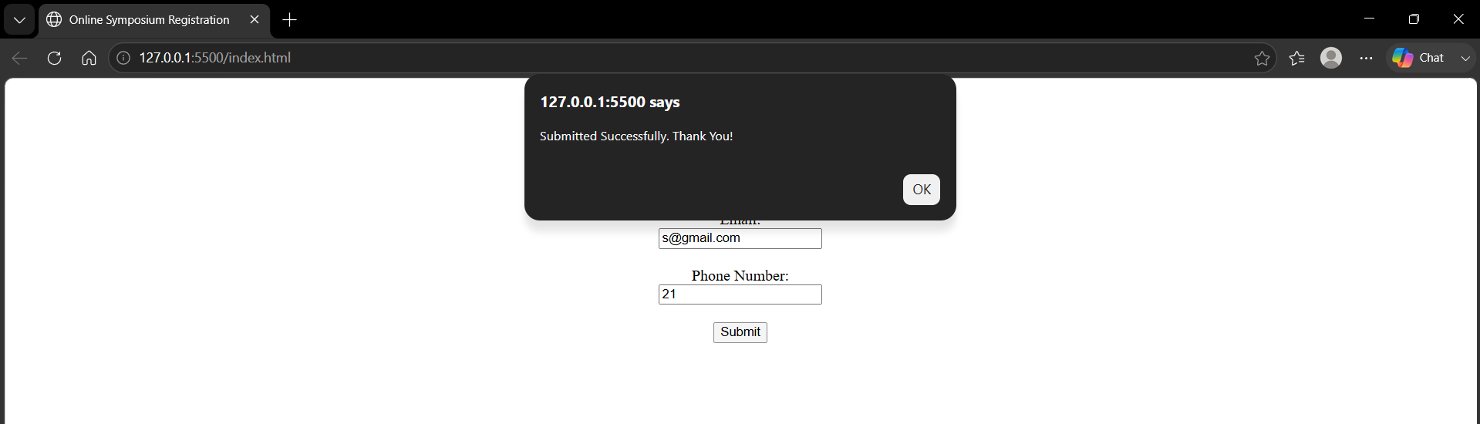
------------------------------------------------------------------------------------------------------------
3. Interpret the HTTP Request Generated During Form Submission
When the user clicks Submit, the browser sends an HTTP POST request to the server.
Example:
POST /register HTTP/1.1
Host: www.college.com
Content-Type: application/x-www-form-urlencoded

name=Rahul&email=rahul@gmail.com
The request contains:
- Request Method → POST
- URL → /register
- Form data → name and email
--------------------------------------------------------------------------------------------------------------
4. Analyze the HTTP Response Cycle
- User submits the form.
- Browser sends HTTP POST request.
- Server receives and processes the data.
- Server stores the registration details.
- Server sends an HTTP response (e.g., 200 OK).
- Browser displays the success page.

5. Improvements for Usability and Accessibility
- Use <label> for every input field.
- Add the required attribute.
- Use meaningful headings.
- Display validation messages.
- Use semantic elements like <header>, <main>, and <section>.
- Ensure keyboard accessibility.
--------------------------------------------------------------------------------------------

2)

1. Identify Improper Nesting and Missing Closing Tags
Errors:
- <h1> is not closed.
- <p> is not closed.
- Missing <!DOCTYPE html>.
- Missing <meta charset="UTF-8">.

2. Browser Interpretation
Different browsers automatically try to fix invalid HTML.
Some browsers may:
- Close missing tags automatically.
- Render the layout differently.
- Produce inconsistent spacing and formatting.
This causes cross-browser compatibility issues.

3. Missing Semantic Elements
Missing semantic tags include:
- <header>
- <main>
- <section>
These improve webpage structure and accessibility.
4. Code

<!DOCTYPE html>
<html lang="en">

<head>
<title>Company</title>
</head>
<body>
<centre>

<div>

<h1>Welcome</h1>
<p>About us</p>
</div>
</centre>
</body>
</html>
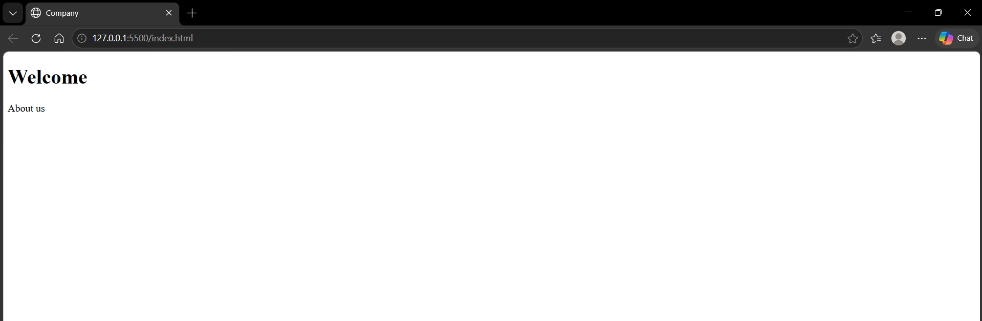
5. Techniques for Cross-Browser Compatibility
- Follow W3C HTML standards.
- Validate HTML using the W3C Validator.
- Use semantic HTML5 elements.
- Test in Chrome, Firefox, Edge, and Safari.
- Use CSS reset or normalize.css.
- Avoid browser-specific features.

3)

3. Form Submission Failure
1. Identify Issues in the Form Configuration
Problems:
- Button type is "button" instead of "submit".
- Password is sent using the GET method.
- GET is not secure for login forms.

2. Why HTTP Request is Not Triggered
The button is:
<button type="button">
A button with type="button" does not submit the form.
Only
<button type="submit">
or
<input type="submit">
will send the HTTP request.

3. Role of GET Method
GET sends form data in the URL.
Example:
/submit?username=Rahul&password=12345
Disadvantages:
- Password is visible in the URL.
- Data is stored in browser history.
- Not suitable for sensitive information.
4. Code
<!DOCTYPE html>
<html>

<head>
<title>Login</title>
</head>

<body>

<center>

<h1>Login</h1>

<form onsubmit="return login()">

<label>Username:</label>
<input type="text" name="username" required>

<br><br>

<label>Password:</label>
<input type="password" name="password" required>

<br><br>

<button type="submit">Login</button>

</form>

</center>

<script>
function login() {
alert("Login Successful!");
return false;
}
</script>

</body>

</html>
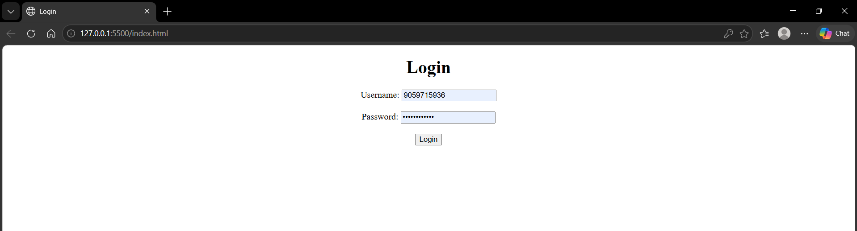
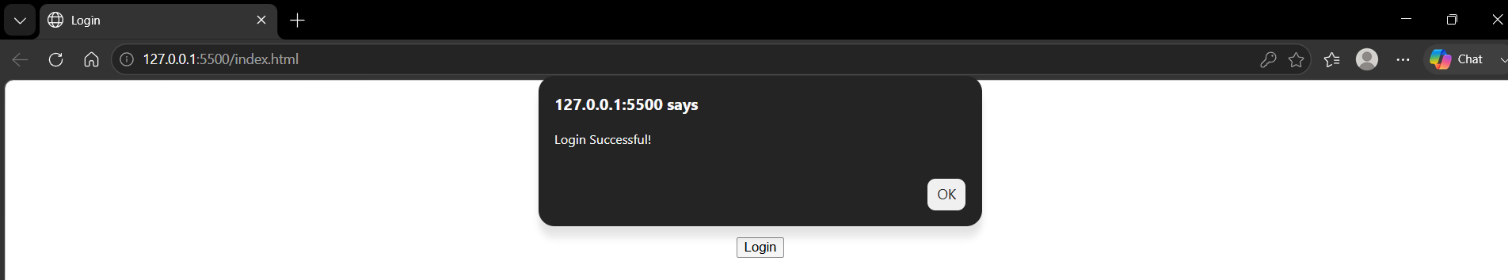

5. Improvements for Secure Data Transmission
- Use the POST method instead of GET.
- Use HTTPS to encrypt communication.
- Validate user inputs on both client and server.
- Store passwords securely using hashing algorithms.
- Implement authentication and session management.

